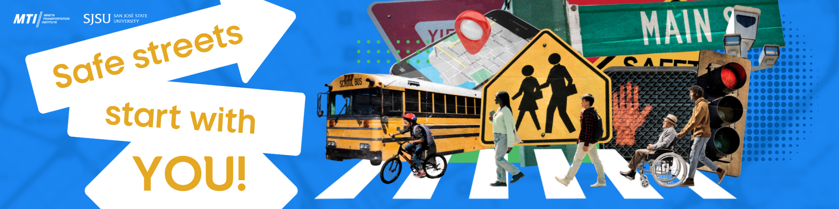

2026 Essay Contest Submission

Safe streets start with YOU!

Student’s Name:

Teacher/mentor’s name:

Teacher/mentor’s email address:

Acknowledgement of support
I hereby acknowledge and confirm that I have reviewed the essay in this application. I also confirm that I am in support of this submission to the Mineta Transportation Institute Essay Contest.

Signature:

